Lab 1: Report on gen_tick

**Table of Contents**

Introduction 1

gen_tick Module 1

Module Code 1

Explanation 2

Test Bench for gen_tick Module 3

Code: 3

Explanation 7

Conclusion 7

# Introduction

This report discusses the implementation and testing of the gen_tick module in Verilog. The gen_tick module generates a tick signal at a specified frequency based on a source clock input. The accompanying test bench verifies the functionality of the gen_tick module by simulating different scenarios and configurations.

# gen_tick Module

The gen_tick module produces a tick signal at a given frequency (TICK_FREQ) from an input source clock (SRC_FREQ). The module includes parameters for the source clock frequency and the desired output tick frequency.

## Module Code

|  |
| --- |
| `timescale 1ns / 1ps  //////////////////////////////////////////////////////////////////////////////////  // Company:  // Engineer:  //  // Create Date: 06/06/2024 06:17:18 PM  // Design Name:  // Module Name: gen_tick  // Project Name:  // Target Devices:  // Tool Versions:  // Description:  //  // Dependencies:  //  // Revision:  // Revision 0.01 - File Created  // Additional Comments:  //  //////////////////////////////////////////////////////////////////////////////////  module gen_tick #(  parameter SRC_FREQ = 5000, // Source clock frequency in Hz  parameter TICK_FREQ = 1 // Output tick frequency in Hz  )(  input src_clk, // Source clock input  input enable, // Enable signal  output tick // Output tick signal  );  // Calculate the number of source clock cycles per tick  localparam integer TICK_COUNT = SRC_FREQ / TICK_FREQ;  // Declare registers and wires here  reg [31:0] counter = 0;  reg tick_reg = 0;  always @(posedge src_clk) begin  if (!enable) begin  counter <= 0;  tick_reg <= 0; // No tick if not enabled  end else begin  if (counter == TICK_COUNT - 1) begin  counter <= 0;  tick_reg <= ~tick_reg; // Toggle the tick signal  end else begin  counter <= counter + 1;  end  end  end  // Assign the tick register to the output tick signal  assign tick = tick_reg;  endmodule |

## Explanation

* Parameters:
  + SRC_FREQ: Frequency of the input source clock in Hz.
  + TICK_FREQ: Desired frequency of the output tick signal in Hz.
* Local Parameters:
  + TICK_COUNT: Number of source clock cycles required for one tick period (SRC_FREQ / TICK_FREQ).
* Registers:
  + counter: A 32-bit register to count the source clock cycles.
  + tick_reg: A register to hold the tick signal state.
* Always Block:
  + If enable is low, counter and tick_reg are reset to 0.
  + If enable is high, counter increments on each rising edge of src_clk.
  + When counter reaches TICK_COUNT - 1, it resets to 0 and toggles the tick_reg signal.
* Output Assignment:
  + The tick output is assigned the value of tick_reg.

# Test Bench for gen_tick Module

The test bench lab01_tb is designed to verify the functionality of the gen_tick module. It instantiates three instances of gen_tick with different configurations and monitors their outputs.

## Code:

|  |
| --- |
| `timescale 1ns / 1ps  module lab01_tb;  // Inputs  reg clk;  reg reset;  // Outputs  // -------------------------------------------------------  // Setup output file for possible debugging uses  // -------------------------------------------------------  initial  begin  $dumpfile("lab01.vcd");  $dumpvars(0);  end  // Declare wires for each unit under test  wire tick_100_2;  wire tick_100_5;  wire tick_100_50;  // -------------------------------------------------------  // Instantiate at least 3 Units Under Test (UUTs)  // -------------------------------------------------------  gen_tick #(.SRC_FREQ(100), .TICK_FREQ(2)) uut_100_2 (  .src_clk(clk),  .enable(1'b1),  .tick(tick_100_2)  );  gen_tick #(.SRC_FREQ(100), .TICK_FREQ(5)) uut_100_5 (  .src_clk(clk),  .enable(1'b1),  .tick(tick_100_5)  );  gen_tick #(.SRC_FREQ(100), .TICK_FREQ(50)) uut_100_50 (  .src_clk(clk),  .enable(1'b1),  .tick(tick_100_50)  );  initial begin  clk = 0; reset = 1; #50;  clk = 1; reset = 1; #50;  clk = 0; reset = 0; #50;  clk = 1; reset = 0; #50;    forever begin  clk = ~clk; #50;  end  end    integer totalTests = 0;  integer failedTests = 0;  integer count = 0;  integer high_count = 0;  reg last_tick = 0;  integer transition_count = 0;  initial begin // Test suite  // Reset  @(negedge reset); // Wait for reset to be released (from another initial block)  @(posedge clk); // Wait for first clock out of reset  #10; // Wait 10 cycles  // ---------------------------------------------  // Testing Source clock 100Hz, Tick 2Hz  // ---------------------------------------------  $write("Test Source clock 100Hz, Tick 2Hz ... ");  totalTests = totalTests + 1;  while(count < 1000) begin  @(posedge clk);  if (last_tick == 0 & tick_100_2 != last_tick) begin  transition_count = transition_count + 1;  end  count = count + 1;  if (tick_100_2 == 1) begin  high_count = high_count + 1;  end  last_tick = tick_100_2;  end  if (high_count == 500 & transition_count == 20) begin  $display("PASSED");  end else begin  $display("FAILED");  failedTests = failedTests + 1;  end  $display("Load (%d/%d): %0.2f", high_count, count, 1.0 * high_count / count);  $display("Transition count: %d", transition_count);  // Re-initialize counters for each test  last_tick = 0;  transition_count = 0;  count = 0;  high_count = 0;  // ---------------------------------------------  // Testing Source clock 100Hz, Tick 5Hz  // ---------------------------------------------  $write("Test Source clock 100Hz, Tick 5Hz ... ");  totalTests = totalTests + 1;  while(count < 1000) begin  @(posedge clk);  if (last_tick == 0 & tick_100_5 != last_tick) begin  transition_count = transition_count + 1;  end  count = count + 1;  if (tick_100_5 == 1) begin  high_count = high_count + 1;  end  last_tick = tick_100_5;  end  if (high_count == 1000 & transition_count == 50) begin  $display("PASSED");  end else begin  $display("FAILED");  failedTests = failedTests + 1;  end  $display("Load (%d/%d): %0.2f", high_count, count, 1.0 * high_count / count);  $display("Transition count: %d", transition_count);  // Re-initialize counters for each test  last_tick = 0;  transition_count = 0;  count = 0;  high_count = 0;  // ---------------------------------------------  // Testing Source clock 100Hz, Tick 50Hz  // ---------------------------------------------  $write("Test Source clock 100Hz, Tick 50Hz ... ");  totalTests = totalTests + 1;  while(count < 1000) begin  @(posedge clk);  if (last_tick == 0 & tick_100_50 != last_tick) begin  transition_count = transition_count + 1;  end  count = count + 1;  if (tick_100_50 == 1) begin  high_count = high_count + 1;  end  last_tick = tick_100_50;  end  if (high_count == 500 & transition_count == 100) begin  $display("PASSED");  end else begin  $display("FAILED");  failedTests = failedTests + 1;  end  $display("Load (%d/%d): %0.2f", high_count, count, 1.0 * high_count / count);  $display("Transition count: %d", transition_count);  $finish;  end  endmodule |

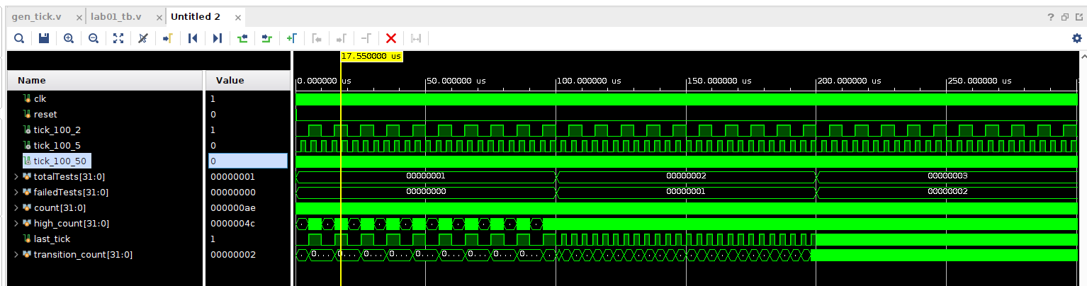

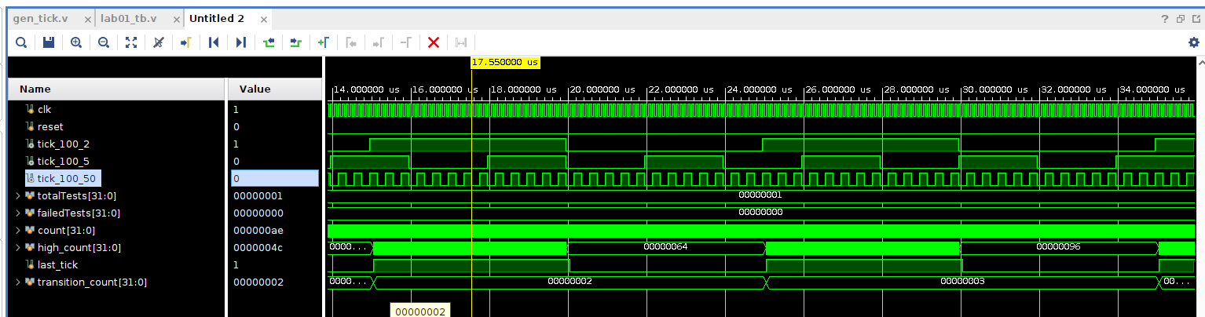

## Explanation

* Inputs:
  + clk: Clock signal for the test bench.
  + reset: Reset signal for the test bench.
* Initialization:
  + $dumpfile and $dumpvars are used for waveform generation.
  + Three instances of the gen_tick module are instantiated with different configurations:
    - uut_100_2 with SRC_FREQ = 100 Hz and TICK_FREQ = 2 Hz.
    - uut_100_5 with SRC_FREQ = 100 Hz and TICK_FREQ = 5 Hz.
    - uut_100_50 with SRC_FREQ = 100 Hz and TICK_FREQ = 50 Hz.
* Clock Generation:
  + The clock signal (clk) is toggled every 50 time units to simulate a 10 MHz clock.
* Test Scenarios:
  + Each test case verifies the tick generation for different configurations by counting the high ticks and transitions over 1000 clock cycles.
  + Test Case 1: SRC_FREQ = 100 Hz, TICK_FREQ = 2 Hz.
    - The expected number of high ticks is 500, and the number of transitions should be 20.
  + Test Case 2: SRC_FREQ = 100 Hz, TICK_FREQ = 5 Hz.
    - The expected number of high ticks is 1000, and the number of transitions should be 50.
  + Test Case 3: SRC_FREQ = 100 Hz, TICK_FREQ = 50 Hz.
    - The expected number of high ticks is 500, and the number of transitions should be 100.
* Output Monitoring:
  + The $display task is used to print the test results, indicating whether each test passed or failed based on the expected output.

# Conclusion

The gen_tick module successfully generates a tick signal at a specified frequency derived from a source clock. The test bench verifies the functionality of the gen_tick module by simulating various configurations and observing the output behavior. The simulation results confirm that the module operates correctly when tested with different source clock and tick frequencies.